# Table of Contents

Introduction 1

Setup 1

Table Columns 2

Adding or Removing Columns 2

Importing into EA 3

Sync with Sparx Worksheet Tab 3

Hide or UnhideRrows 4

Creating Objects in EA 5

# Introduction

The Excel Importer Spreadsheet’s intended purpose is to avoid having to create many objects in EA manually, instead the spreadsheet can be filled out and executed, and it will create the objects in EA for the user.

The spreadsheet can also be helpful in making mass changes to EA objects; it will save time to edit a column in excel rather than having to manual change an object’s property value 1 by 1.

In the future, it will also be useful for syncing data in the spreadsheet to or from EA objects

# SETUP

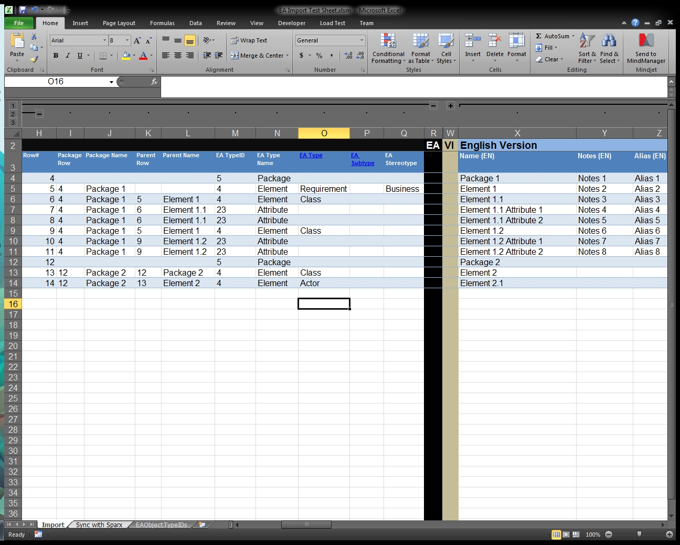

1. **Table Columns**

* **Parent Row**
  + Change or Input a number to denote the parent of a row’s object.
  + If left blank the parent will default to the row of the package in the Package Row column.
* **Package Row**
  + Input the row of the package that the object is under.
  + Leave this value blank if the object belongs under the starting package.
* **EA TypeID**
  + Select from the drop down what type of object the row represents.
  + Number representation can be found in the EAObjectTypeIDs worksheet tab.
* **EA Type**
  + Select the type of the object from the drop down.
  + An Element MUST have a type.
  + Refer to the EAObjectTypeIDs worksheet tab for a full list of types.
* **EA Stereotype**
  + Type the name of the Stereotype of the object, CAP sensitive.
* **Status**
  + Select from the drop down the status of the object.
  + Refer to the EAObjectTypeIDs worksheet tab for a list of statuses.
* **Version**
  + Type in the version number.
* **Name**
  + Type in the name of the object.
* **Notes**
  + Type in the notes for the object.
* **Alias**
  + Type in the Alias for the object.

1. **Adding or Removing Columns**

* **Adding a New Column**
  + To Add a Tagged Value, in Row 1 in a new column type in Either TagValue or TagNotes followed by _NameOfTaggedValueGoesHere.
  + Make sure the column is added as part of the table.
  + Row 3 is used for user convenience to tell what the column represents.
* **Removing a Column**
  + To remove a column, simply right click on the column letter and select delete.
  + Make sure the deleted column is no longer part of the table.

# Importing into EA

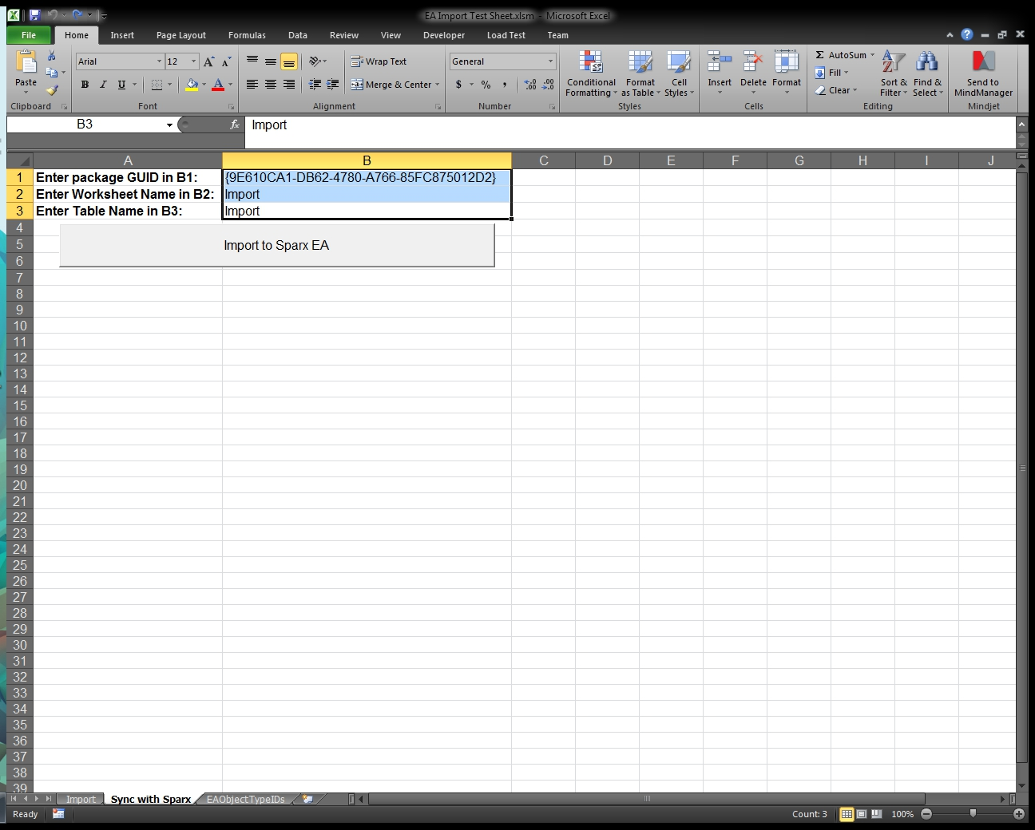

1. **Sync with Sparx worksheet tab**
   * Enter in the Package GUID under which the objects will be created in cell B1. An objects GUID can be found in Sparx EA, with the object selected -> Properties -> Project -> GUID.

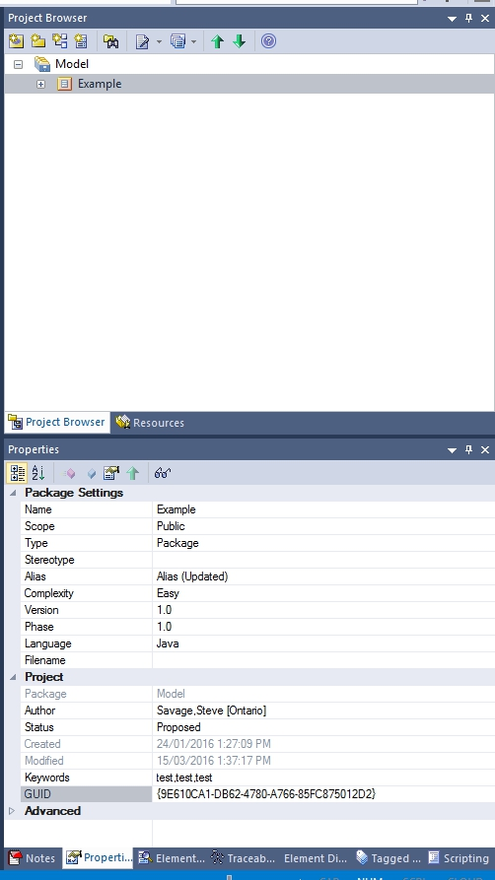

* + Enter in the name of the worksheet that will be imported into EA in cell B2.
  + Enter in the name of the table containing the data of the worksheet in cell B3.

1. **Hide or Unhide rows to edit visible information**
   * To unhide a row or a column, highlight (left click hold and drag) the rows or columns surrounding the hidden row or column. Then right click one of the surrounding highlighted row or column and select ‘unhide’, or select a row or column and right click -> ‘Hide’ to hide that row or column

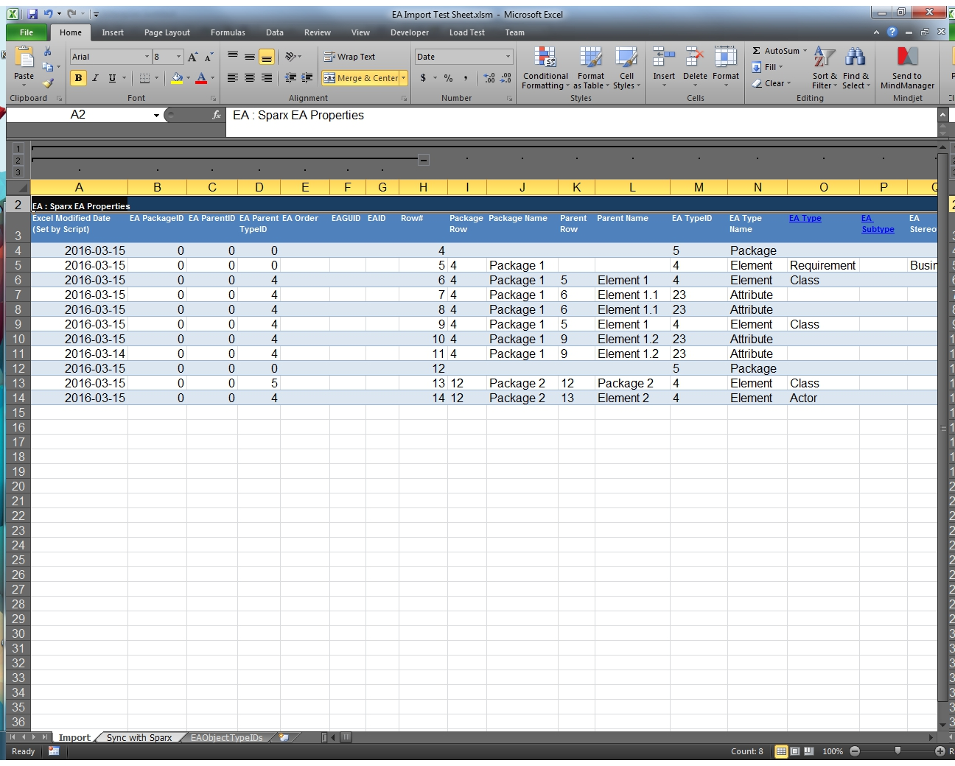

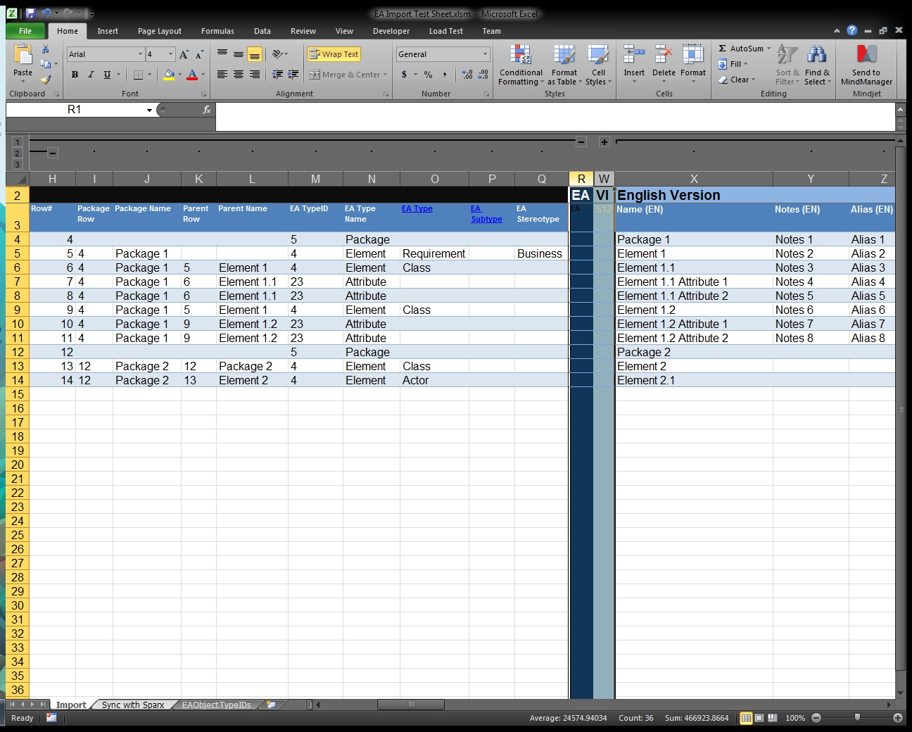

1. **Creating the objects in Sparx EA**
   * Click the Button ‘Import to Sparx EA’, If invalid information was entered, or information was left blank the user will be prompted to enter the information now. Select ‘yes’ at the prompt to begin creating the objects or ‘no’ to exit.